 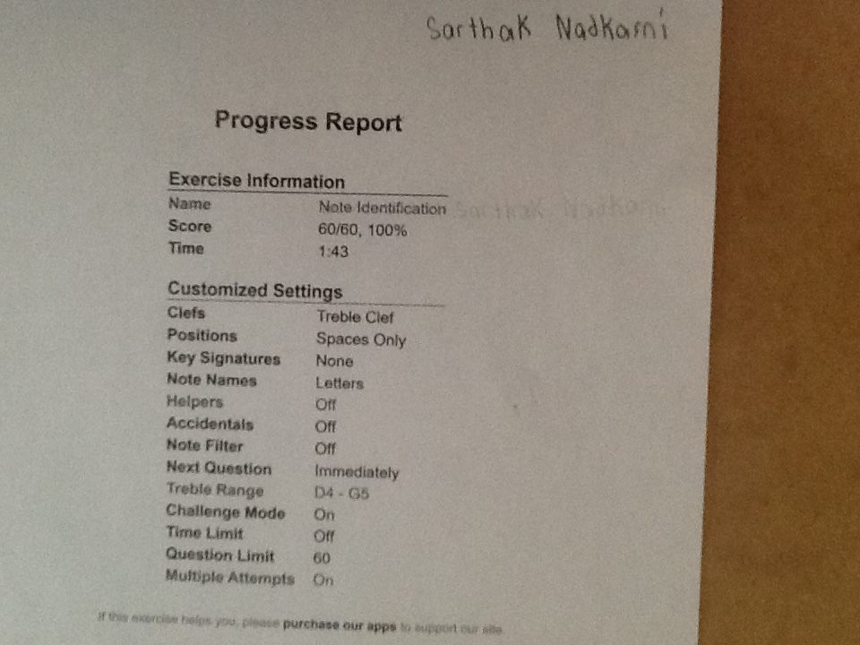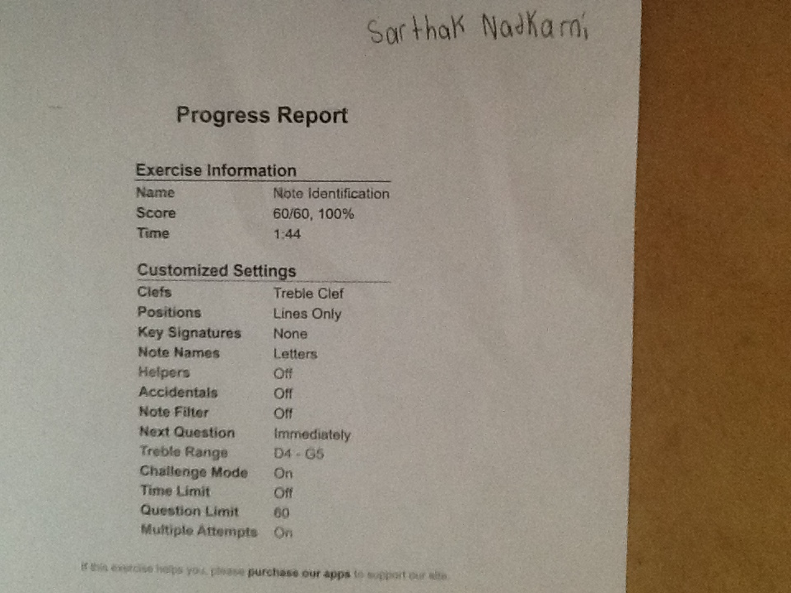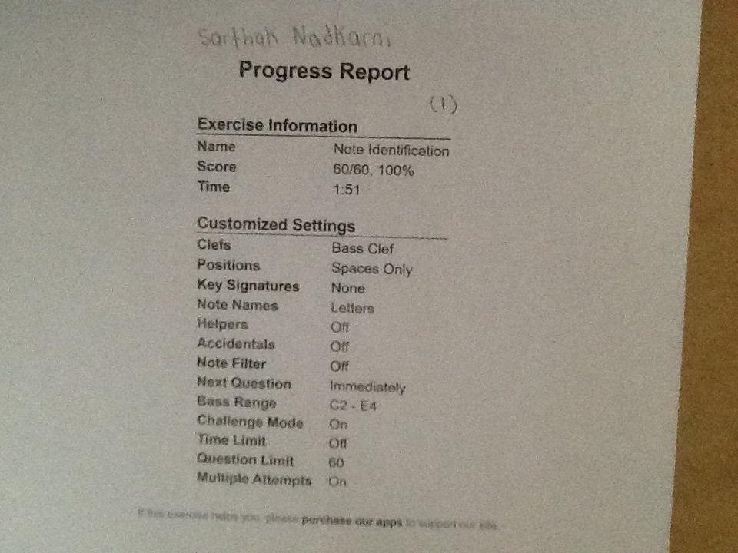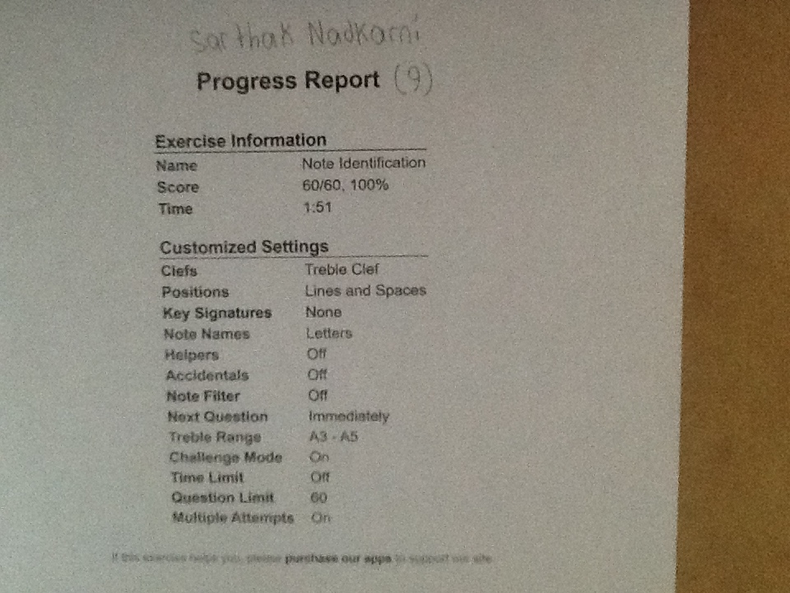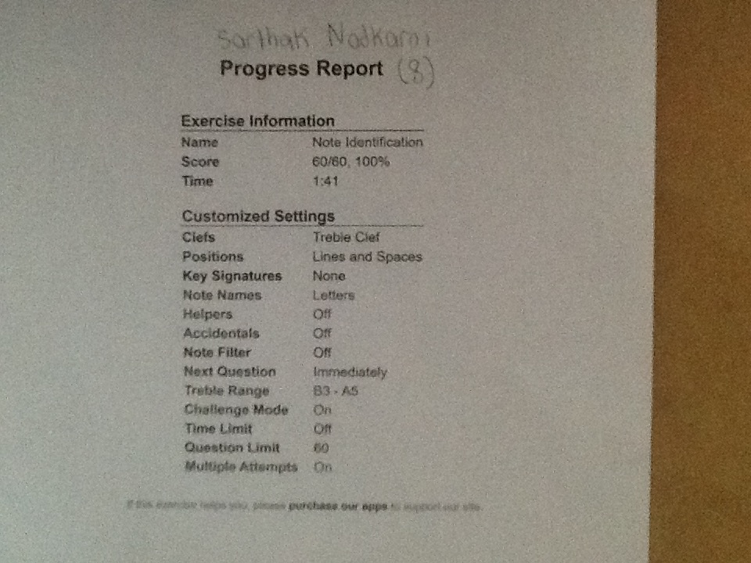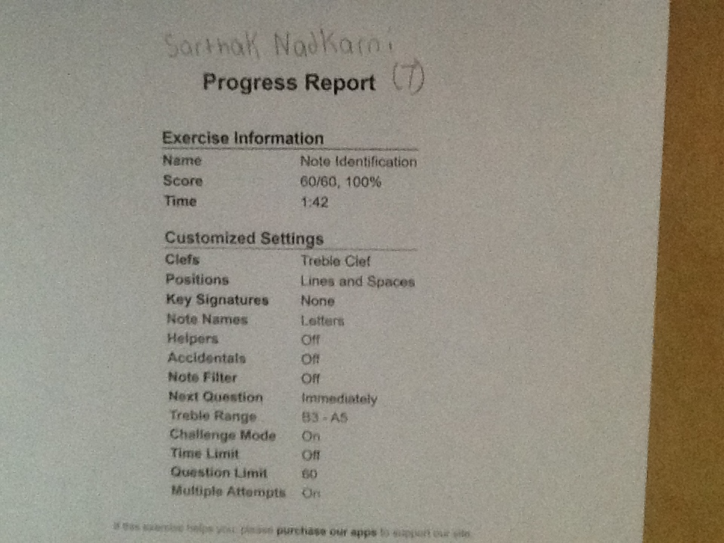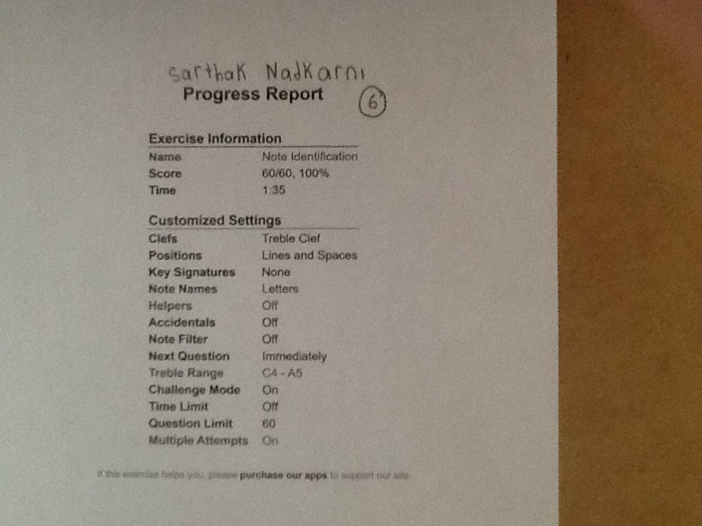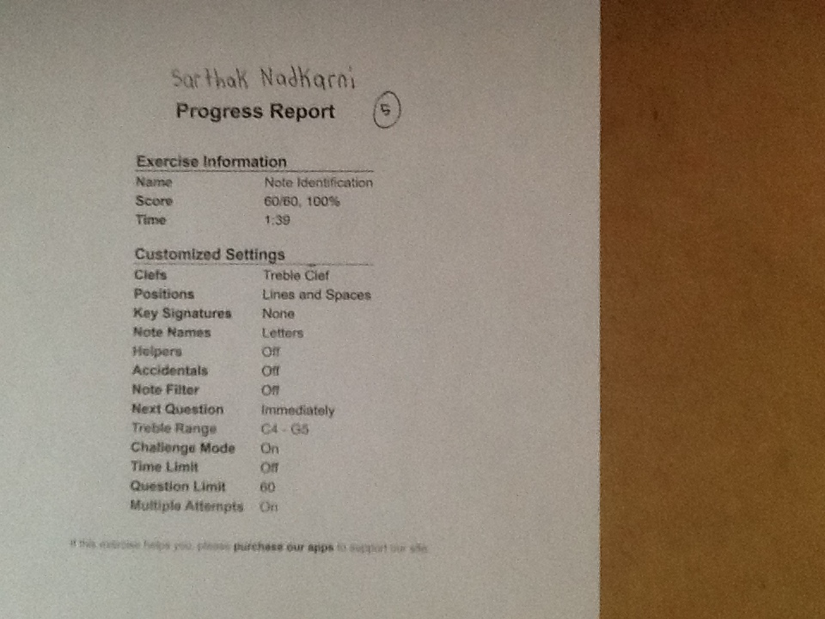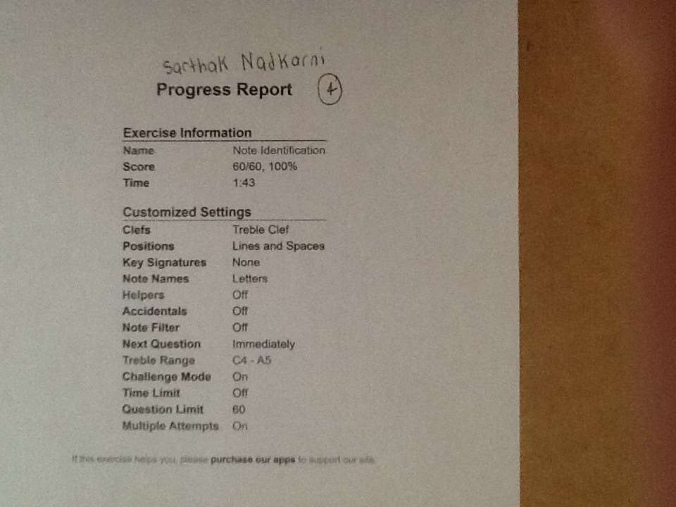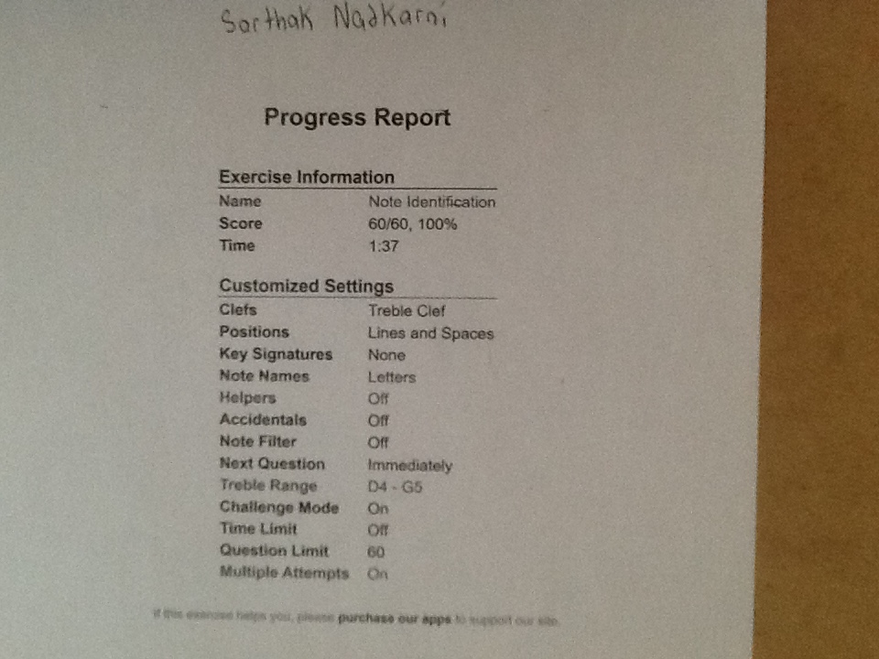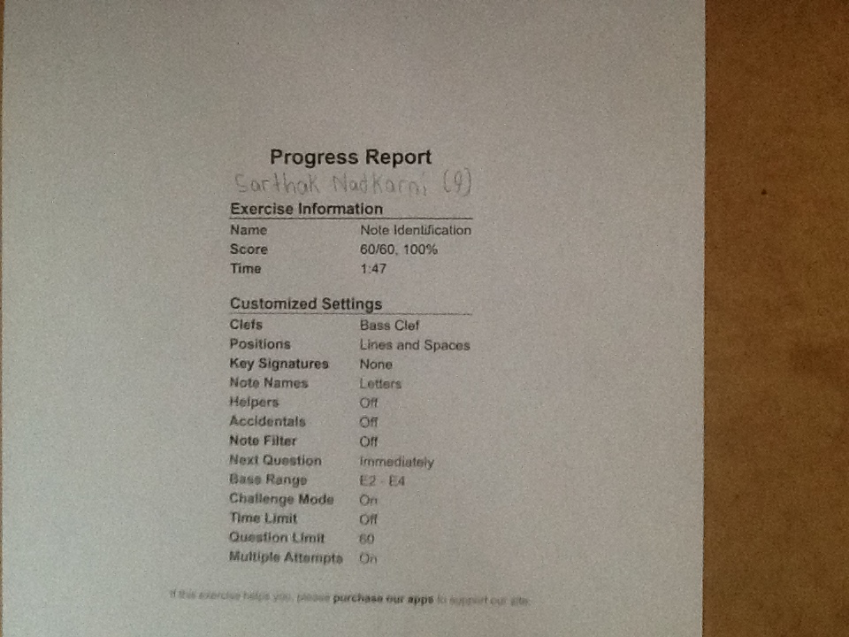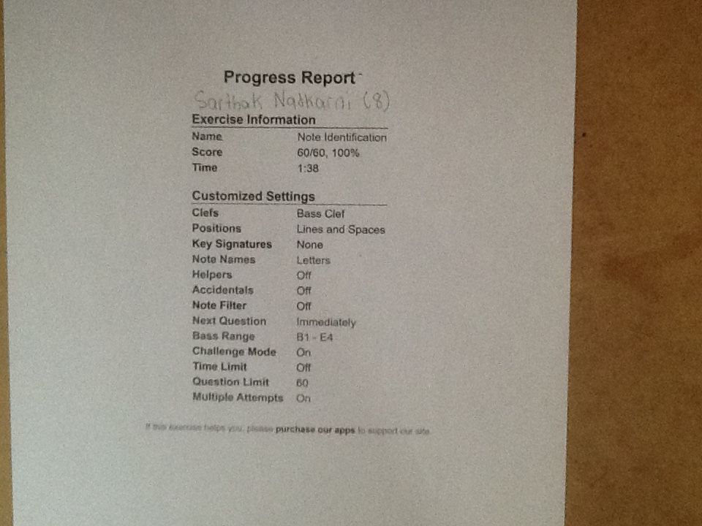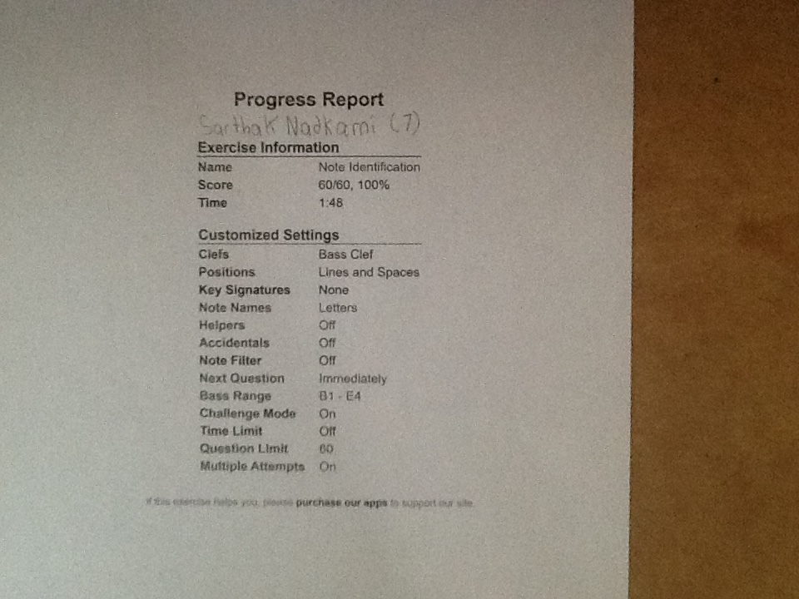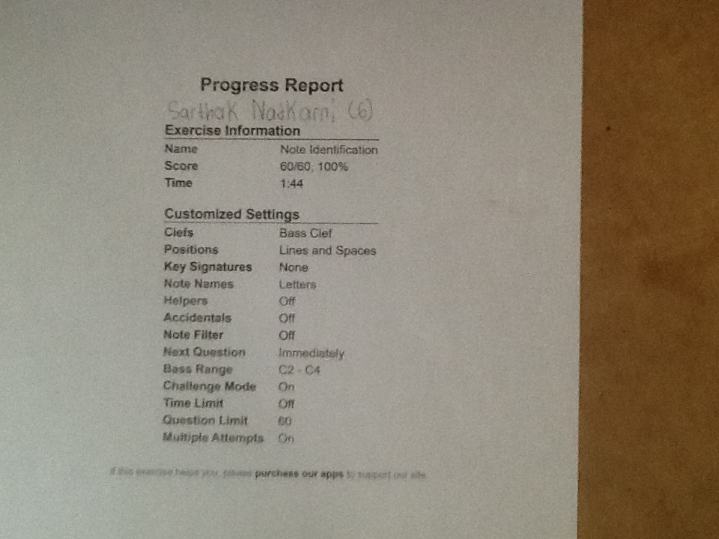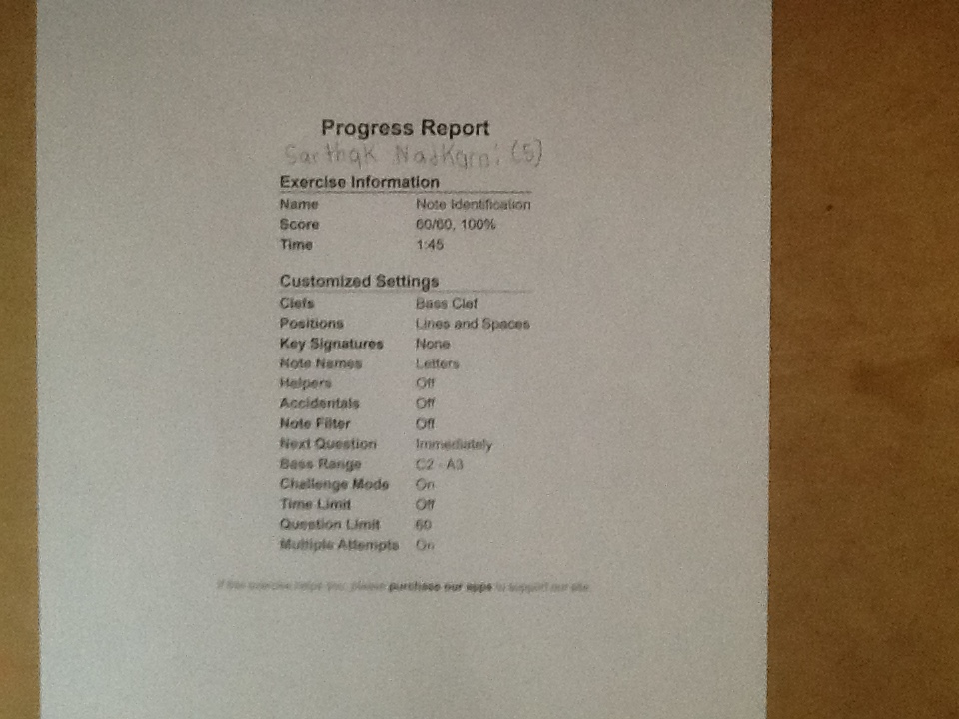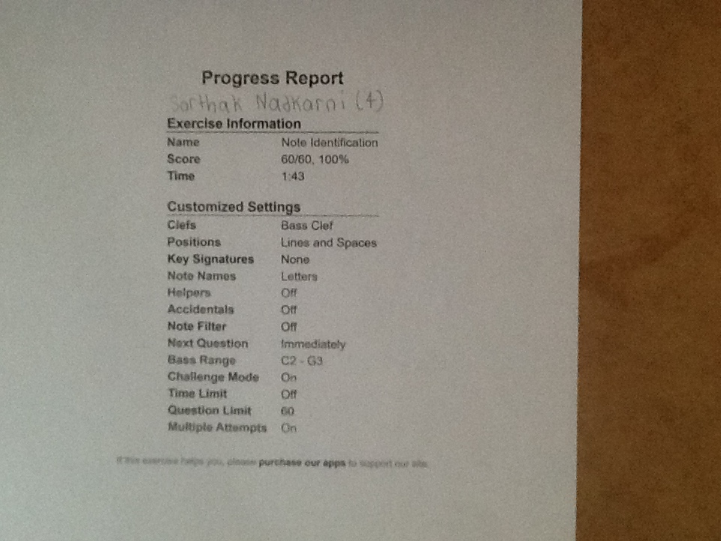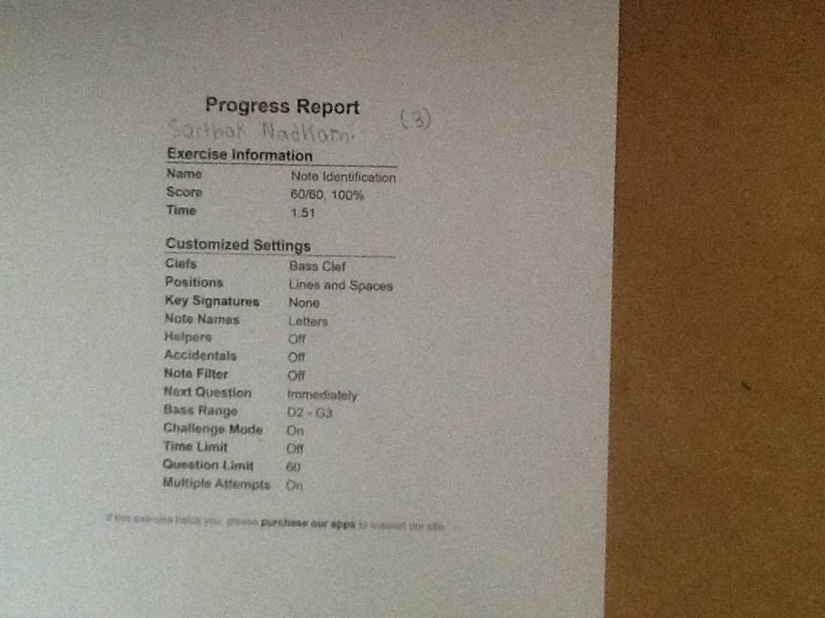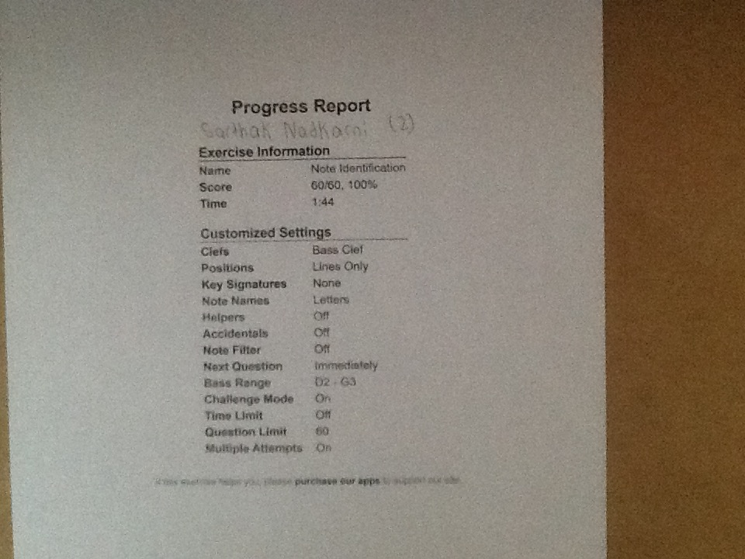

Musician: ________________________________ Homeroom: ____________ Grade: ______

As you start your musical journey with Mr Gough and Ms Sheridan, you are a “Beginner”. Spend as

*little time*

in the

levels as possible. This handout will help you record and remember your progress as we play together this semester.

Achievement, recognition

and respect from both your peers and your directors await you as you proceed. Good luck and

have fun!

**Level #1 (Orange)**

****

Reading

-

I can follow music with my eyes…almost all of the time

****

Mad Minute

-

#8 unassisted. 60/60 in your preferred clef.

****

Rhythm

-

Boo

t Camp, page 10, no mistakes.

****

Rehearsal Warm Up

–

I need support and/or reminders/correction.

****

Cycle of Fourths

–

I know where I start on the sheet

****

Motivation

–

I can ask for help and I know when I need support.

Student Leader Signature ___________________

_________________________

**Level #2 (Blue)**

****

Reading

-

I can play my parts with reasonable accuracy. I make a mistakes, but don’t often get lost.

****

Mad Minute

-

#10 unassisted. In your preferred clef, under 2:30.

****

Rhythm

–

Stix with accurate performance. Rhyth

m Boot Camp page 15.

****

Rehearsal Warm Up

–

I know my four assigned warm up tasks and do some of them.

****

Cycle of Fourths

–

I can play the first 6 notes with assistance (checking on one or two fingerings)

****

Motivation

–

I know when I am lost or make a mistake. I

regularly ask for help.

Students Leader Signature___________________________________________________

**Level #3 (Yellow)**

****

Reading

–

I can play my parts with confidence. Rhythms and notes are mostly correct.

****

Mad Minute

–

#15 unassisted, in both clefs, under 1

:45. Treble ___ Bass ___

****

Rhythm

–

Stix with accurate performance (solo). Rhythm Boot Camp page 21.

****

Rehearsal Warm Up

o

Mouthpiece work: WW

-

I can almost pitch match, crow; Brass

–

I can buzz Hot cross Buns or another simple song of 3 notes,

Strings

–

I do stretches, bowing techniques and simple scale patterns in Bb, Eb, F , Percussion

–

I work exclusively on mallet

percussion hand over hand technique, rolls

o

Long Tones, Articulation & Flow Studies in Bb (I Recommend Pg 7 at 60bpm

****

Cycle of

Fourths

–

I can play the LAST 6 notes with assistance (checking on one or two fingerings)